Statistical Analysis Plan

Project: Lipid lowering therapy in patients with heart failure
Researcher: Anton Berg, Erik Thunström, Carmen Basic

July 4, 2025

Authored by:
Konstantinos Konstantinou, Statistician, Konstantinos.konstantinou@apnc.se +76 400 20 09
Reviewed by:
Andrea Dahl Sturedahl, Statistician, andrea.dahl.sturedahl@apnc.se, +76 504 77 74

Revisions:
Nr | Description | Date
1 | First version | 2025-06-26
2 | Updates:  - The baseline for all results is changed to 6 months after index date. All tables and Figures are updated.  - Table 1 shows number of people excluded from the analysis due to missing follow-up data  - Baseline Table: Added number (%) of HF medication per type of medication before baseline (6 months from index), and ICD/CRT within 1 year after baseline, IHD 30 days prior to index date  - Table 5: Added all-cause mortality, CV death and MACE outcomes  New table:  - Table 2.2. shows number of dispensed prescriptions for each type of LLT per period as well as last dosage taken before baseline. | 2025-07-03

Table of Contents
Statistical Considerations 5
Methods 5
Tables 6
Table 1. Inclusion/Exclusion table 6
Table 2.1. Characteristics at baseline (6 months after index date) for different periods (FAS population) 7
Table 2.2. Number of different type of lipid lowering therapies and dosage taken before baseline, for different periods (FAS population) 10
Table 3. Effect of lipid lowering treatment on one-year all-cause mortality from 6 months after index date, for different subgroups and periods (FAS population) 13
Table 4.1 Effect of lipid lowering treatment on one-year cardiovascular mortality from 6 months after index date, for different subgroups and periods (FAS population) 15
Table 4.2 Effect of lipid lowering treatment on one-year MACE from 6 months after index date, for different subgroups and periods (FAS population) 17
Table 5. Event rates, number of events, follow-up time and HR (Cox regression with IPTW) for on one-year all-cause mortality, one-year CV death and one-year MACE, from 3 months after index date (FAS population) 19
Figures 20
Figure 1.1. Effect of lipid lowering therapy on one-year all-cause mortality from 6 months after index date, for different subgroups and periods (FAS population) 20
Figure 1.2. Effect of lipid lowering therapy on one-year cardiovascular mortality from 6 months after index date, for different subgroups and periods (FAS population) 21
Figure 1.3. Effect of lipid lowering therapy on one-year MACE from 6 months after index date, for different subgroups and periods (FAS population) 22
Figure 2.1. Kaplan-Meier plot of one-year all-cause mortality for lipid lowering therapy (Yes vs No) from 6 months after index date, during different periods (FAS population) 23
Figure 2.2. Kaplan-Meier plot of one-year all-cause mortality for lipid lowering therapy (Yes vs No) from 6 months after index date, by sex (FAS population) 24
Figure 2.3. Kaplan-Meier plot of one-year all-cause survival for lipid lowering therapy (Yes vs No) from 6 months after index date, by ischemic heart disease (IHD: Yes vs No) 30 days prior to index (FAS population) 25
Figure 2.4. Kaplan-Meier plot of one-year all-cause survival for lipid lowering therapy from 6 months after index date, by different age groups (<75 vs >=75 years) (FAS population) 26
Figure 3.1. Kaplan-Meier plot for the secondary outcomes for lipid lowering therapy (Yes vs No), from 6 months after index date (FAS population) 27

Statistical Considerations

Methods

Descriptively, continuous variables are presented by mean±standard deviation, median (range) and categorical variables by frequency (percentage). Differences between groups were assess using Mann-Whitney U tests, chi-square tests of Fisher’s exact test as appropriate.
Multivariable Cox proportional hazard models were used to assess the hazard ratio (HR) of lipid lowering therapy (LLT) for the primary outcome of one-year all-cause mortality and secondary outcomes of one-year CV death and one-year MACE, starting 6 months after the index date. Analyses across different subgroups based on ischemic heart disease (30 days prior to index), gender and age category for different time periods are also presented.
Additional models incorporating an extra interaction term between subgroups and LLT were used to obtain the p-value for the joint effect of interaction. To examine, the join interaction between different time periods and LLT, an additional variable accounting for the period and an interaction term between period and LLT were included. The p-values for this joint effect are also presented. All models were adjusted for covariates, including age, sex, IHD, diabetes, hypertension, atrial fibrillation, cancer last 3 years and heart failure medications usage.
Propensity scores based on age, sex, IHD, diabetes, hypertension, atrial fibrillation, cancer last 3 years and heart failure medications usage were calculated, and Cox regression with inverse probability treatment weighting (IPTW) procedure was used. Event rates were calculated as number of events divided by the number of follow-up years and expressed by 10000 person years. The 95% CI for the event rate was estimated using Poisson limits.
All test were two-tailed and conducted at 5% significance level. All analysis datasets were created using R software version 4.3.0. and all statistical analyses were performed using SAS software version 9.4 (SAS Institute Inc., Cary, NC, USA).

Tables

Table 1. Inclusion/Exclusion table
Variable | Total  N=762244 | No LLT  N=530488 (70%) | LLT  N=231756 (30%)
Excluded due to age (<18 years) at HF diagnosis
No | 760829 (99.8%) | 529078 (99.7%) | 231751 (100.0%)
Yes | 1415 (0.2%) | 1410 (0.3%) | 5 (0.0%)
Excluded due to first HF diagnosis between 1996-2005
No | 517453 (67.9%) | 292234 (55.1%) | 225219 (97.2%)
Yes | 244791 (32.1%) | 238254 (44.9%) | 6537 (2.8%)
Excluded due to dying within 6 months from index date
No | 604633 (79.3%) | 401185 (75.6%) | 203448 (87.8%)
Yes | 157611 (20.7%) | 129303 (24.4%) | 28308 (12.2%)
Excluded due to 6 months after index being after end of study
No | 745891 (97.9%) | 522821 (98.6%) | 223070 (96.3%)
Yes | 16353 (2.1%) | 7667 (1.4%) | 8686 (3.7%)
Included in the study
No | 363438 (47.7%) | 321456 (60.6%) | 41982 (18.1%)
Yes | 398806 (52.3%) | 209032 (39.4%) | 189774 (81.9%)
Data are presented number of observations (percentage).
A patient can be represented in more than one exclusion category.

Table 2.1. Characteristics at baseline (6 months after index date) for different periods (FAS population)
 | 2006 - 2011 |  |  | 2012 - 2018 |  |  | 2019 - 2022 |  |  | 2006 - 2022
Variable | No LLT | LLT | p | No LLT | LLT | p | No LLT | LLT | p | No LLT | LLT | p
Age | 77.7±12.3  81.0 (18.0 - 102.0)  n=77679 | 73.8±10.3  75.0 (19.0 - 99.0)  n=60691 | <.0001 | 77.9±13.5  81.0 (18.0 - 104.0)  n=88496 | 75.1±10.4  76.0 (18.0 - 101.0)  n=80510 | <.0001 | 76.9±14.3  80.0 (18.0 - 104.0)  n=42857 | 75.9±10.5  77.0 (19.0 - 106.0)  n=48573 | <.0001 | 77.6±13.3  81.0 (18.0 - 104.0)  n=209032 | 74.9±10.4  76.0 (18.0 - 106.0)  n=189774 | <.0001
Sex |  |  | <.0001 |  |  | <.0001 |  |  | <.0001 |  |  | <.0001
Male | 38572 (49.7%) | 37292 (61.4%) |  | 41473 (46.9%) | 49999 (62.1%) |  | 20467 (47.8%) | 30139 (62.0%) |  | 100512 (48.1%) | 117430 (61.9%)
Female | 39107 (50.3%) | 23399 (38.6%) |  | 47023 (53.1%) | 30511 (37.9%) |  | 22390 (52.2%) | 18434 (38.0%) |  | 108520 (51.9%) | 72344 (38.1%)
Ischemic Heart Disease (IHD) |  |  | <.0001 |  |  | <.0001 |  |  | <.0001 |  |  | <.0001
No | 55698 (71.7%) | 17496 (28.8%) |  | 67386 (76.1%) | 27088 (33.6%) |  | 35147 (82.0%) | 19421 (40.0%) |  | 158231 (75.7%) | 64005 (33.7%)
Yes | 21981 (28.3%) | 43195 (71.2%) |  | 21110 (23.9%) | 53422 (66.4%) |  | 7710 (18.0%) | 29152 (60.0%) |  | 50801 (24.3%) | 125769 (66.3%)
Ischemic Heart Disease (IHD)- 30 days before index date |  |  | <.0001 |  |  | <.0001 |  |  | <.0001 |  |  | <.0001
No | 71281 (91.8%) | 45844 (75.5%) |  | 84180 (95.1%) | 64633 (80.3%) |  | 41377 (96.5%) | 39891 (82.1%) |  | 196838 (94.2%) | 150368 (79.2%)
Yes | 6398 (8.2%) | 14847 (24.5%) |  | 4316 (4.9%) | 15877 (19.7%) |  | 1480 (3.5%) | 8682 (17.9%) |  | 12194 (5.8%) | 39406 (20.8%)
Diabetes |  |  | <.0001 |  |  | <.0001 |  |  | <.0001 |  |  | <.0001
No | 65303 (84.1%) | 41073 (67.7%) |  | 74696 (84.4%) | 51777 (64.3%) |  | 36436 (85.0%) | 30777 (63.4%) |  | 176435 (84.4%) | 123627 (65.1%)
Yes | 12376 (15.9%) | 19618 (32.3%) |  | 13800 (15.6%) | 28733 (35.7%) |  | 6421 (15.0%) | 17796 (36.6%) |  | 32597 (15.6%) | 66147 (34.9%)
Hypertension |  |  | <.0001 |  |  | <.0001 |  |  | <.0001 |  |  | <.0001
No | 38104 (49.1%) | 20990 (34.6%) |  | 30440 (34.4%) | 17215 (21.4%) |  | 13948 (32.5%) | 8906 (18.3%) |  | 82492 (39.5%) | 47111 (24.8%)
Yes | 39575 (50.9%) | 39701 (65.4%) |  | 58056 (65.6%) | 63295 (78.6%) |  | 28909 (67.5%) | 39667 (81.7%) |  | 126540 (60.5%) | 142663 (75.2%)
Stroke/TIA |  |  | <.0001 |  |  | <.0001 |  |  | <.0001 |  |  | <.0001
No | 67898 (87.4%) | 50616 (83.4%) |  | 78685 (88.9%) | 65739 (81.7%) |  | 39161 (91.4%) | 39661 (81.7%) |  | 185744 (88.9%) | 156016 (82.2%)
Yes | 9781 (12.6%) | 10075 (16.6%) |  | 9811 (11.1%) | 14771 (18.3%) |  | 3696 (8.6%) | 8912 (18.3%) |  | 23288 (11.1%) | 33758 (17.8%)
Chronic obstructive pulmonary disease |  |  | 1.00 |  |  |  |  |  | 1.00 |  |  | 1.00
No | 77678 (100.0%) | 60690 (100.0%) |  | 88496 (100.0%) | 80510 (100.0%) |  | 42855 (100.0%) | 48571 (100.0%) |  | 209029 (100.0%) | 189771 (100.0%)
Yes | 1 (0.0%) | 1 (0.0%) |  |  |  |  | 2 (0.0%) | 2 (0.0%) |  | 3 (0.0%) | 3 (0.0%)
Atrial fibrillation |  |  | <.0001 |  |  | <.0001 |  |  | <.0001 |  |  | <.0001
No | 39777 (51.2%) | 36572 (60.3%) |  | 39952 (45.1%) | 43623 (54.2%) |  | 18270 (42.6%) | 24994 (51.5%) |  | 97999 (46.9%) | 105189 (55.4%)
Yes | 37902 (48.8%) | 24119 (39.7%) |  | 48544 (54.9%) | 36887 (45.8%) |  | 24587 (57.4%) | 23579 (48.5%) |  | 111033 (53.1%) | 84585 (44.6%)
Valvular surgery |  |  | <.0001 |  |  | <.0001 |  |  | <.0001 |  |  | <.0001
No | 76231 (98.1%) | 58711 (96.7%) |  | 86227 (97.4%) | 77102 (95.8%) |  | 41581 (97.0%) | 46242 (95.2%) |  | 204039 (97.6%) | 182055 (95.9%)
Yes | 1448 (1.9%) | 1980 (3.3%) |  | 2269 (2.6%) | 3408 (4.2%) |  | 1276 (3.0%) | 2331 (4.8%) |  | 4993 (2.4%) | 7719 (4.1%)
Cancer last 3 years |  |  | <.0001 |  |  | <.0001 |  |  | <.0001 |  |  | <.0001
No | 64980 (83.7%) | 52419 (86.4%) |  | 72921 (82.4%) | 67561 (83.9%) |  | 34856 (81.3%) | 40364 (83.1%) |  | 172757 (82.6%) | 160344 (84.5%)
Yes | 12699 (16.3%) | 8272 (13.6%) |  | 15575 (17.6%) | 12949 (16.1%) |  | 8001 (18.7%) | 8209 (16.9%) |  | 36275 (17.4%) | 29430 (15.5%)
Implantable cardioverter defibrillator/ cardiac resynchronization therapy |  |  | <.0001 |  |  | <.0001 |  |  | <.0001 |  |  | <.0001
No | 76991 (99.1%) | 59426 (97.9%) |  | 87336 (98.7%) | 78398 (97.4%) |  | 42242 (98.6%) | 47458 (97.7%) |  | 206569 (98.8%) | 185282 (97.6%)
Yes | 688 (0.9%) | 1265 (2.1%) |  | 1160 (1.3%) | 2112 (2.6%) |  | 615 (1.4%) | 1115 (2.3%) |  | 2463 (1.2%) | 4492 (2.4%)
Implantable cardioverter defibrillator/cardiac resynchronization therapy within 1 year after baseline |  |  | <.0001 |  |  | <.0001 |  |  | <.0001 |  |  | <.0001
No | 77329 (99.5%) | 60011 (98.9%) |  | 87953 (99.4%) | 79522 (98.8%) |  | 42677 (99.6%) | 48187 (99.2%) |  | 207959 (99.5%) | 187720 (98.9%)
Yes | 350 (0.5%) | 680 (1.1%) |  | 543 (0.6%) | 988 (1.2%) |  | 180 (0.4%) | 386 (0.8%) |  | 1073 (0.5%) | 2054 (1.1%)
Heart failure medication
Beta-blocker |  |  | <.0001 |  |  | <.0001 |  |  | <.0001 |  |  | <.0001
No | 21717 (28.0%) | 6441 (10.6%) |  | 15780 (17.8%) | 5781 (7.2%) |  | 6387 (14.9%) | 3418 (7.0%) |  | 43884 (21.0%) | 15640 (8.2%)
Yes | 55962 (72.0%) | 54250 (89.4%) |  | 72716 (82.2%) | 74729 (92.8%) |  | 36470 (85.1%) | 45155 (93.0%) |  | 165148 (79.0%) | 174134 (91.8%)
Angiotensin Converting Enzyme inhibitor/Angiotensin Receptor Blocker |  |  | <.0001 |  |  | <.0001 |  |  | <.0001 |  |  | <.0001
No | 23185 (29.8%) | 8144 (13.4%) |  | 17890 (20.2%) | 6890 (8.6%) |  | 7894 (18.4%) | 3844 (7.9%) |  | 48969 (23.4%) | 18878 (9.9%)
Yes | 54494 (70.2%) | 52547 (86.6%) |  | 70606 (79.8%) | 73620 (91.4%) |  | 34963 (81.6%) | 44729 (92.1%) |  | 160063 (76.6%) | 170896 (90.1%)
Angiotensin Receptor Neprilysin inhibitor |  |  | <.0001 |  |  | <.0001 |  |  | <.0001 |  |  | <.0001
No | 77679 (100.0%) | 60691 (100.0%) |  | 88126 (99.6%) | 79989 (99.4%) |  | 40531 (94.6%) | 45044 (92.7%) |  | 206336 (98.7%) | 185724 (97.9%)
Yes |  |  |  | 370 (0.4%) | 521 (0.6%) |  | 2326 (5.4%) | 3529 (7.3%) |  | 2696 (1.3%) | 4050 (2.1%)
Mineralocorticoid Receptor Antagonist |  |  | 0.96 |  |  | <.0001 |  |  | <.0001 |  |  | <.0001
No | 55154 (71.0%) | 43100 (71.0%) |  | 59394 (67.1%) | 51557 (64.0%) |  | 25038 (58.4%) | 26197 (53.9%) |  | 139586 (66.8%) | 120854 (63.7%)
Yes | 22525 (29.0%) | 17591 (29.0%) |  | 29102 (32.9%) | 28953 (36.0%) |  | 17819 (41.6%) | 22376 (46.1%) |  | 69446 (33.2%) | 68920 (36.3%)
Sodium-Glucose Cotransporter 2 inhibitor |  |  | 0.96 |  |  | <.0001 |  |  | <.0001 |  |  | <.0001
No | 77679 (100.0%) | 60691 (100.0%) |  | 88302 (99.8%) | 79443 (98.7%) |  | 39220 (91.5%) | 40294 (83.0%) |  | 205201 (98.2%) | 180428 (95.1%)
Yes |  |  |  | 194 (0.2%) | 1067 (1.3%) |  | 3637 (8.5%) | 8279 (17.0%) |  | 3831 (1.8%) | 9346 (4.9%)
Data are presented as mean±standard deviation, median (range) and number of observations, or number (%).
For test between two groups with respect to dichotomous variables Chi-square test was used, and for continuous variables Mann-Whitney U test.

Table 2.2. Number of different types of lipid lowering therapies and dosage taken before baseline, for different periods (FAS population)
Variable | 2006 - 2011 | 2012 - 2018 | 2019 - 2022 | P-value
Number of dispensed prescriptions
Simvastatin |  |  |  | <.0001
No | 77895 (56.3%) | 92857 (54.9%) | 54192 (59.3%)
Yes | 60475 (43.7%) | 76149 (45.1%) | 37238 (40.7%)
Pravastatin |  |  |  | <.0001
No | 112964 (81.6%) | 134044 (79.3%) | 73898 (80.8%)
Yes | 25406 (18.4%) | 34962 (20.7%) | 17532 (19.2%)
Fluvastatin |  |  |  | <.0001
No | 114093 (82.5%) | 135823 (80.4%) | 74845 (81.9%)
Yes | 24277 (17.5%) | 33183 (19.6%) | 16585 (18.1%)
Atorvastatin |  |  |  | <.0001
No | 107979 (78.0%) | 104073 (61.6%) | 50019 (54.7%)
Yes | 30391 (22.0%) | 64933 (38.4%) | 41411 (45.3%)
Rosuvastatin |  |  |  | <.0001
No | 113260 (81.9%) | 132263 (78.3%) | 68730 (75.2%)
Yes | 25110 (18.1%) | 36743 (21.7%) | 22700 (24.8%)
Omega-3 |  |  |  | <.0001
No | 114412 (82.7%) | 136124 (80.5%) | 74976 (82.0%)
Yes | 23958 (17.3%) | 32882 (19.5%) | 16454 (18.0%)
Ezetimib |  |  |  | <.0001
No | 113092 (81.7%) | 132173 (78.2%) | 69518 (76.0%)
Yes | 25278 (18.3%) | 36833 (21.8%) | 21912 (24.0%)
Evolokumab |  |  |  | <.0001
No | 114415 (82.7%) | 136120 (80.5%) | 74872 (81.9%)
Yes | 23955 (17.3%) | 32886 (19.5%) | 16558 (18.1%)
Alirokumab |  |  |  | <.0001
No | 114415 (82.7%) | 136137 (80.6%) | 74916 (81.9%)
Yes | 23955 (17.3%) | 32869 (19.4%) | 16514 (18.1%)
Inclisirans |  |  |  | <.0001
No | 114415 (82.7%) | 136140 (80.6%) | 74985 (82.0%)
Yes | 23955 (17.3%) | 32866 (19.4%) | 16445 (18.0%)
Bezafibrat |  |  |  | <.0001
No | 114132 (82.5%) | 135767 (80.3%) | 74809 (81.8%)
Yes | 24238 (17.5%) | 33239 (19.7%) | 16621 (18.2%)
Fenofibrat |  |  |  | <.0001
No | 114282 (82.6%) | 135881 (80.4%) | 74787 (81.8%)
Yes | 24088 (17.4%) | 33125 (19.6%) | 16643 (18.2%)
Inegy |  |  |  | <.0001
No | 114411 (82.7%) | 136063 (80.5%) | 74928 (82.0%)
Yes | 23959 (17.3%) | 32943 (19.5%) | 16502 (18.0%)
Defined daily dosage
Simvastatin defined daily dosage | 107.39±55.91  130.67 (9.33 - 333.33)  n=60475 | 104.05±62.16  66.67 (9.33 - 333.33)  n=76149 | 102.48±62.62  70.00 (9.33 - 333.33)  n=37238 | <.0001
Pravastatin defined daily dosage | 105.79±59.08  83.33 (9.33 - 333.33)  n=25406 | 101.38±64.50  66.67 (9.33 - 333.33)  n=34962 | 99.04±63.87  66.67 (9.33 - 333.33)  n=17532 | <.0001
Fluvastatin defined daily dosage | 105.77±60.14  83.33 (9.33 - 333.33)  n=24277 | 101.47±65.79  66.67 (9.33 - 333.33)  n=33183 | 99.05±65.17  66.67 (9.33 - 333.33)  n=16584 | <.0001
Atorvastatin defined daily dosage | 115.80±78.03  100.00 (9.33 - 400.00)  n=30391 | 165.18±120.51  133.33 (9.33 - 500.00)  n=64933 | 189.15±135.43  133.33 (9.33 - 500.00)  n=41411 | <.0001
Rosuvastatin defined daily dosage | 108.46±63.77  100.00 (9.33 - 392.00)  n=25110 | 108.56±75.27  66.67 (9.33 - 400.00)  n=36743 | 137.26±109.53  100.00 (9.33 - 400.00)  n=22700 | <.0001
Omega-3 defined daily dosage | 106.31±60.20  83.33 (9.33 - 333.33)  n=23955 | 101.79±65.92  66.67 (9.33 - 333.33)  n=32866 | 99.22±65.31  66.67 (9.33 - 333.33)  n=16445 | <.0001
Ezetimib defined daily dosage | 105.53±58.88  98.00 (9.33 - 333.33)  n=25278 | 100.90±62.58  70.00 (9.33 - 333.33)  n=36833 | 98.69±56.96  98.00 (9.33 - 333.33)  n=21912 | <.0001
Evolokumab defined daily dosage | 106.31±60.20  83.33 (9.33 - 333.33)  n=23955 | 101.78±65.91  66.67 (9.33 - 333.33)  n=32886 | 99.06±65.14  66.67 (9.33 - 333.33)  n=16558 | <.0001
Alirokumab defined daily dosage | 106.31±60.20  83.33 (9.33 - 333.33)  n=23955 | 101.79±65.90  66.67 (9.33 - 333.33)  n=32869 | 99.30±65.27  66.67 (9.33 - 333.33)  n=16514 | <.0001
Inclisirans defined daily dosage | 106.30±60.19  83.33 (9.33 - 333.33)  n=23955 | 101.78±65.91  66.67 (9.33 - 333.33)  n=32866 | 99.22±65.31  66.67 (9.33 - 333.33)  n=16445 | <.0001
Bezafibrat defined daily dosage | 105.63±60.17  83.33 (9.33 - 333.33)  n=24238 | 101.20±65.82  66.67 (9.33 - 333.33)  n=33239 | 98.69±65.18  66.67 (9.33 - 333.33)  n=16621 | <.0001
Fenofibrat defined daily dosage | 106.24±60.04  100.00 (9.33 - 333.33)  n=24088 | 101.71±65.70  66.67 (9.33 - 333.33)  n=33125 | 99.12±64.96  66.67 (9.33 - 333.33)  n=16643 | <.0001
Inegy defined daily dosage | 106.30±60.18  83.33 (9.33 - 333.33)  n=23959 | 101.77±65.85  66.67 (9.33 - 333.33)  n=32943 | 99.22±65.20  66.67 (9.33 - 333.33)  n=16502 | <.0001
Data are presented as mean±standard deviation, median (range) and number of observations, or number(%).
For test between two groups with respect to dichotomous variables Chi-square test was used, and for continuous variables Kruskall-Wallis test.

Table 3. Effect of lipid lowering treatment on one-year all-cause mortality from 6 months after index date, for different subgroups and periods (FAS population)

Period | Subgroup | LLT (Yes vs No)  HR (95% CI) | p-value  Interaction with subgroup | p-value  Interaction with period
2006 - 2023 | All | 0.69 (0.67 - 0.70)  p=<.0001 |  | 0.18
 | IHD: No | 0.75 (0.74 - 0.77)  p=<.0001 | <.001 | 0.06
 | IHD: Yes | 0.58 (0.55 - 0.62)  p=<.0001 |  | 0.15
 | Male | 0.68 (0.66 - 0.70)  p=<.0001 | <.001 | 0.96
 | Female | 0.70 (0.68 - 0.72)  p=<.0001 |  | 0.018
 | < 75 years | 0.61 (0.58 - 0.64)  p=<.0001 | <.001 | 0.13
 | >= 75 years | 0.72 (0.71 - 0.74)  p=<.0001 |  | 0.38
2019 - 2023 | All | 0.72 (0.69 - 0.75)  p=<.0001
 | IHD: No | 0.78 (0.75 - 0.81)  p=<.0001 | <.001
 | IHD: Yes | 0.55 (0.48 - 0.65)  p=<.0001
 | Male | 0.70 (0.66 - 0.74)  p=<.0001 | 0.006
 | Female | 0.73 (0.69 - 0.78)  p=<.0001
 | < 75 years | 0.67 (0.59 - 0.75)  p=<.0001 | 0.006
 | >= 75 years | 0.74 (0.71 - 0.77)  p=<.0001
2012 - 2018 | All | 0.68 (0.66 - 0.70)  p=<.0001
 | IHD: No | 0.74 (0.71 - 0.76)  p=<.0001 | <.001
 | IHD: Yes | 0.57 (0.52 - 0.63)  p=<.0001
 | Male | 0.68 (0.65 - 0.71)  p=<.0001 | 0.47
 | Female | 0.67 (0.64 - 0.70)  p=<.0001
 | < 75 years | 0.58 (0.54 - 0.62)  p=<.0001 | <.001
 | >= 75 years | 0.72 (0.70 - 0.74)  p=<.0001
2006 - 2011 | All | 0.68 (0.66 - 0.71)  p=<.0001
 | IHD: No | 0.75 (0.73 - 0.78)  p=<.0001 | <.001
 | IHD: Yes | 0.60 (0.55 - 0.66)  p=<.0001
 | Male | 0.66 (0.63 - 0.70)  p=<.0001 | 0.003
 | Female | 0.71 (0.67 - 0.74)  p=<.0001
 | < 75 years | 0.61 (0.56 - 0.66)  p=<.0001 | <.001
 | >= 75 years | 0.72 (0.70 - 0.75)  p=<.0001
Cox regression adjusted for age, sex, IHD, diabetes, hypertension, atrial fibrillation, cancer last 3 years, Betablocker, Mineralocorticoid Receptor Antagonist, Sodium-Glucose Cotransporter 2 inhibitor, Angiotensin Receptor Neprilysin inhibitor, Angiotensin Converting Enzyme inhibitor/Angiotensin Receptor Blocker was used for time to event analyses presented by HR.

Table 4.1 Effect of lipid lowering treatment on one-year cardiovascular mortality from 6 months after index date, for different subgroups and periods (FAS population)

Period | Subgroup | LLT (Yes vs No)  HR (95% CI) | p-value  Interaction with subgroup | p-value  Interaction with period
2006 - 2023 | All | 0.73 (0.71 - 0.75)  p=<.0001 |  | 0.030
 | IHD: No | 0.82 (0.80 - 0.85)  p=<.0001 | <.001 | 0.004
 | IHD: Yes | 0.63 (0.58 - 0.69)  p=<.0001 |  | 0.06
 | Male | 0.71 (0.69 - 0.74)  p=<.0001 | 0.25 | 0.16
 | Female | 0.75 (0.72 - 0.78)  p=<.0001 |  | 0.39
 | < 75 years | 0.71 (0.65 - 0.77)  p=<.0001 | 0.044 | 0.49
 | >= 75 years | 0.75 (0.73 - 0.78)  p=<.0001 |  | 0.08
2019 - 2023 | All | 0.74 (0.69 - 0.79)  p=<.0001
 | IHD: No | 0.82 (0.77 - 0.88)  p=<.0001 | 0.022
 | IHD: Yes | 0.56 (0.44 - 0.70)  p=<.0001
 | Male | 0.72 (0.66 - 0.80)  p=<.0001 | 0.48
 | Female | 0.75 (0.68 - 0.83)  p=<.0001
 | < 75 years | 0.78 (0.62 - 0.98)  p=0.037 | 0.30
 | >= 75 years | 0.76 (0.70 - 0.81)  p=<.0001
2012 - 2018 | All | 0.77 (0.73 - 0.80)  p=<.0001
 | IHD: No | 0.83 (0.80 - 0.87)  p=<.0001 | 0.39
 | IHD: Yes | 0.71 (0.62 - 0.81)  p=<.0001
 | Male | 0.75 (0.70 - 0.79)  p=<.0001 | 0.97
 | Female | 0.78 (0.74 - 0.83)  p=<.0001
 | < 75 years | 0.73 (0.65 - 0.83)  p=<.0001 | 0.17
 | >= 75 years | 0.80 (0.76 - 0.84)  p=<.0001
2006 - 2011 | All | 0.77 (0.73 - 0.81)  p=<.0001
 | IHD: No | 0.89 (0.85 - 0.94)  p=<.0001 | <.001
 | IHD: Yes | 0.65 (0.58 - 0.73)  p=<.0001
 | Male | 0.75 (0.71 - 0.80)  p=<.0001 | 0.72
 | Female | 0.79 (0.74 - 0.85)  p=<.0001
 | < 75 years | 0.68 (0.60 - 0.78)  p=<.0001 | 0.43
 | >= 75 years | 0.80 (0.76 - 0.84)  p=<.0001
Cox regression adjusted for age, sex, IHD, diabetes, hypertension, atrial fibrillation, cancer last 3 years, Betablocker, Mineralocorticoid Receptor Antagonist, Sodium-Glucose Cotransporter 2 inhibitor, Angiotensin Receptor Neprilysin inhibitor, Angiotensin Converting Enzyme inhibitor/Angiotensin Receptor Blocker was used for time to event analyses presented by HR.

Table 4.2 Effect of lipid lowering treatment on one-year MACE from 6 months after index date, for different subgroups and periods (FAS population)
Period | Subgroup | LLT (Yes vs No)  HR (95% CI) | p-value  Interaction with subgroup | p-value  Interaction with period
2006 - 2023 | All | 0.76 (0.75 - 0.77)  p=<.0001 |  | <.001
 | IHD: No | 0.85 (0.83 - 0.86)  p=<.0001 | <.001 | <.001
 | IHD: Yes | 0.67 (0.64 - 0.70)  p=<.0001 |  | 0.20
 | Male | 0.74 (0.72 - 0.76)  p=<.0001 | <.001 | 0.08
 | Female | 0.78 (0.76 - 0.80)  p=<.0001 |  | 0.003
 | < 75 years | 0.74 (0.71 - 0.77)  p=<.0001 | 0.004 | 0.18
 | >= 75 years | 0.78 (0.76 - 0.80)  p=<.0001 |  | 0.021
2019 - 2023 | All | 0.76 (0.73 - 0.79)  p=<.0001
 | IHD: No | 0.83 (0.80 - 0.86)  p=<.0001 | 0.038
 | IHD: Yes | 0.63 (0.55 - 0.72)  p=<.0001
 | Male | 0.74 (0.70 - 0.78)  p=<.0001 | 0.024
 | Female | 0.78 (0.74 - 0.82)  p=<.0001
 | < 75 years | 0.77 (0.70 - 0.85)  p=<.0001 | 0.027
 | >= 75 years | 0.78 (0.75 - 0.81)  p=<.0001
2012 - 2018 | All | 0.75 (0.73 - 0.77)  p=<.0001
 | IHD: No | 0.83 (0.81 - 0.86)  p=<.0001 | 0.09
 | IHD: Yes | 0.66 (0.61 - 0.71)  p=<.0001
 | Male | 0.74 (0.72 - 0.77)  p=<.0001 | 0.18
 | Female | 0.76 (0.73 - 0.79)  p=<.0001
 | < 75 years | 0.72 (0.68 - 0.76)  p=<.0001 | 0.11
 | >= 75 years | 0.78 (0.76 - 0.81)  p=<.0001
2006 - 2011 | All | 0.78 (0.76 - 0.81)  p=<.0001
 | IHD: No | 0.89 (0.86 - 0.92)  p=<.0001 | 0.002
 | IHD: Yes | 0.71 (0.66 - 0.77)  p=<.0001
 | Male | 0.76 (0.73 - 0.79)  p=<.0001 | <.001
 | Female | 0.81 (0.78 - 0.85)  p=<.0001
 | < 75 years | 0.76 (0.72 - 0.81)  p=<.0001 | 0.68
 | >= 75 years | 0.81 (0.78 - 0.84)  p=<.0001
Cox regression adjusted for age, sex, IHD, diabetes, hypertension, atrial fibrillation, cancer last 3 years, Betablocker, Mineralocorticoid Receptor Antagonist, Sodium-Glucose Cotransporter 2 inhibitor, Angiotensin Receptor Neprilysin inhibitor, Angiotensin Converting Enzyme inhibitor/Angiotensin Receptor Blocker was used for time to event analyses presented by HR.

Table 5. Event rates, number of events, follow-up time and HR (Cox regression with IPTW) for on one-year all-cause mortality, one-year CV death and one-year MACE, from 3 months after index date (FAS population)

 | LLT |  |  | No LLT |  |  | LLT vs No LLT
Endpoint | n/N (%) events | Follow-up time  Median (IQR) | Event rate (95% CI) per 10000 person-years | n/N (%) events | Follow-up time  Median (IQR) | Event rate (95% CI) per 10000 person-years | * Hazard ratio (95% CI)  p-value
One-year all-cause mortality | 20320/189774  (10.7%) | 365.00 (365.00-365.00)  Sum=65333055 | 3.1 (3.1-3.2) | 35052/209032  (16.8%) | 365.00 (365.00-365.00)  Sum=69405929 | 5.1 (5.0-5.1) | 0.69 (0.68 - 0.70)  p=<.0001
One-year cardiovascular death | 9830/189774  (5.2%) | 365.00 (365.00-365.00)  Sum=67332572 | 1.5 (1.4-1.5) | 16523/209032  (7.9%) | 365.00 (365.00-365.00)  Sum=73041935 | 2.3 (2.2-2.3) | 0.73 (0.72 - 0.75)  p=<.0001
One-year MACE | 29447/189774  (15.5%) | 365.00 (365.00-365.00)  Sum=63246645 | 4.7 (4.6-4.7) | 41185/209032  (19.7%) | 365.00 (365.00-365.00)  Sum=68032462 | 6.1 (6.0-6.1) | 0.75 (0.74 - 0.76)  p=<.0001
All-cause mortality | 109828/189774  (57.9%) | 1334.00 (554.00-2530.00)  Sum=324504819 | 3.4 (3.4-3.4) | 144568/209032  (69.2%) | 1090.00 (439.00-2159.00)  Sum=310463484 | 4.7 (4.7-4.7) | 0.79 (0.78 - 0.79)  p=<.0001
Cardiovascular death | 49855/189774  (26.3%) | 1860.00 (786.00-3443.00)  Sum=419501786 | 1.2 (1.2-1.2) | 65958/209032  (31.6%) | 1855.00 (750.00-3572.00)  Sum=469826351 | 1.4 (1.4-1.4) | 0.91 (0.90 - 0.92)  p=<.0001
MACE | 118560/189774  (62.5%) | 1111.00 (418.00-2233.00)  Sum=285622492 | 4.2 (4.2-4.2) | 148805/209032  (71.2%) | 964.00 (369.00-1982.00)  Sum=286049511 | 5.2 (5.2-5.2) | 0.81 (0.81 - 0.82)  p=<.0001
Confidence interval for unadjusted event rates per 10000 person-years are obtained from exact Poisson confidence limits.
Cox regression was used for time to any event presented by HR.
For the diagnoses outcomes, patients with diagnoses before baseline are excluded.
Propensity scores are calculated based on age, sex, IHD last, diabetes, hypertension, atrial fibrillation, cancer last 3 years, Betablocker, Mineralocorticoid Receptor Antagonist, Sodium-Glucose Cotransporter 2 inhibitor, Angiotensin Receptor Neprilysin inhibitor, Angiotensin Converting Enzyme inhibitor/Angiotensin Receptor Blocker was used for time to event analyses presented by HR.
In the analyses inverse probability weighting is used
* Adjusted for age, sex, IHD last, diabetes, hypertension, atrial fibrillation, cancer last 3 years, Betablocker, Mineralocorticoid Receptor Antagonist, Sodium-Glucose Cotransporter 2 inhibitor, Angiotensin Receptor Neprilysin inhibitor, Angiotensin Converting Enzyme inhibitor/Angiotensin Receptor Blocker was used for time to event analyses presented by HR.

Figures
Figure 1.1. Effect of lipid lowering therapy on one-year all-cause mortality from 6 months after index date, for different subgroups and periods (FAS population)
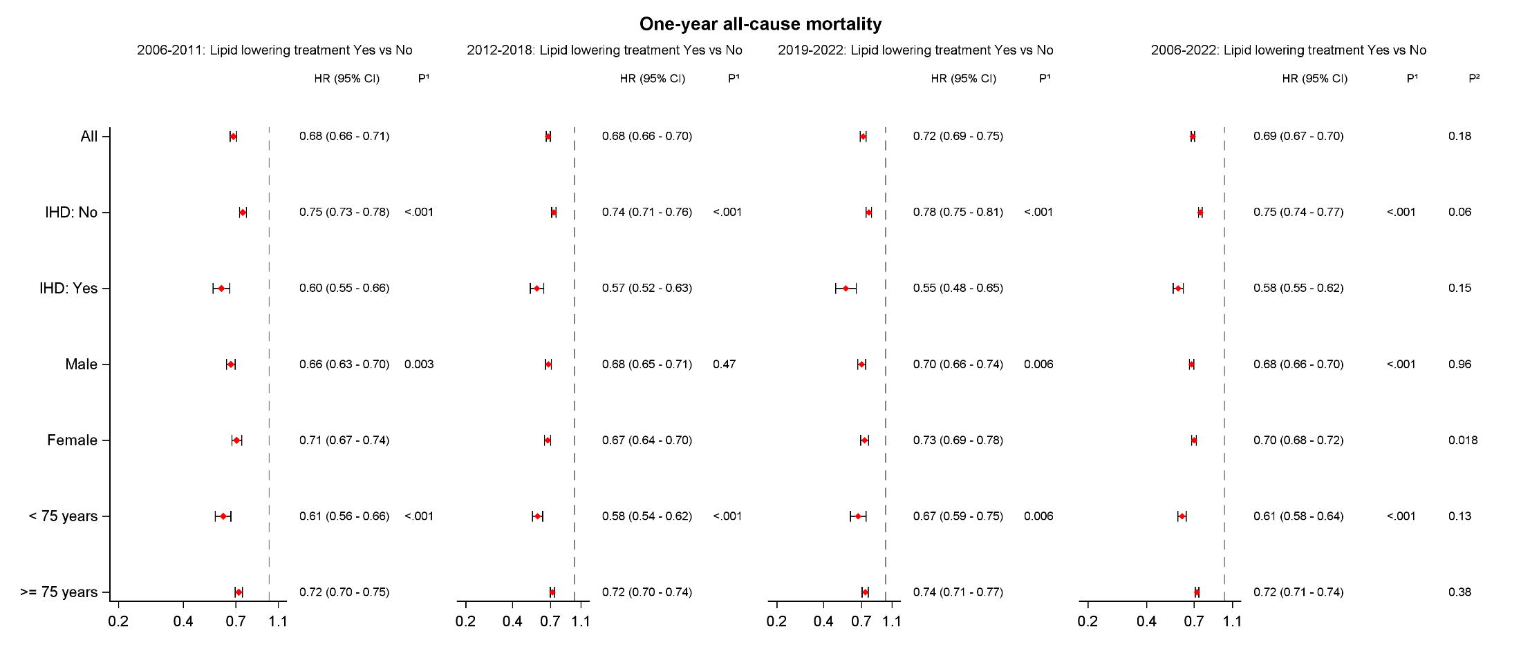
P¹ : P-value for joint effect of interaction between lipid lowering therapy and subgroup
P²: P-value for joint effect of interaction between lipid lowering therapy and different periods

Figure 1.2. Effect of lipid lowering therapy on one-year cardiovascular mortality from 6 months after index date, for different subgroups and periods (FAS population)

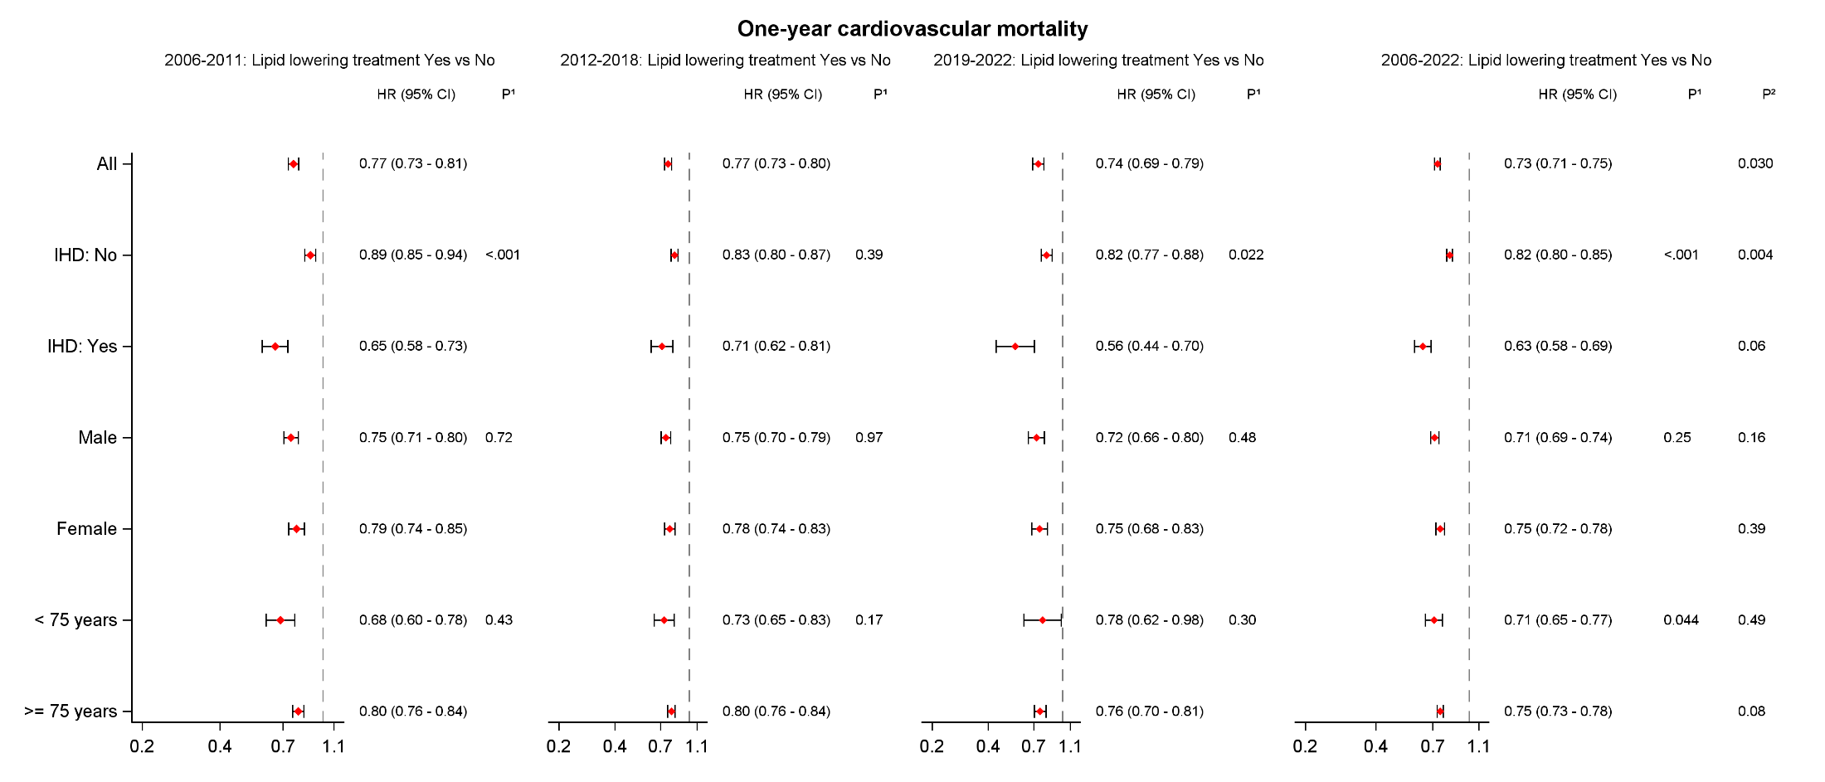
P¹ : P-value for joint effect of interaction between lipid lowering therapy and subgroup
P²: P-value for joint effect of interaction between lipid lowering therapy and different periods

Figure 1.3. Effect of lipid lowering therapy on one-year MACE from 6 months after index date, for different subgroups and periods (FAS population)

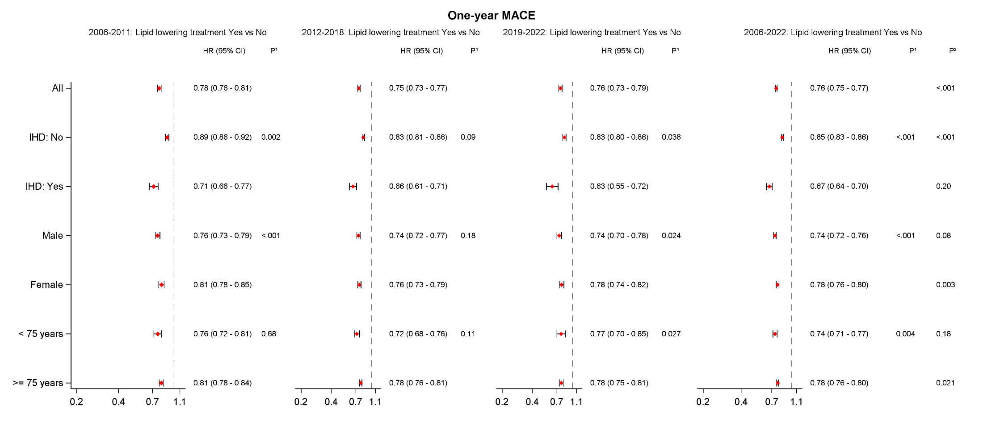
P¹ : P-value for joint effect of interaction between lipid lowering therapy and subgroup
P²: P-value for joint effect of interaction between lipid lowering therapy and different periods

Figure 2.1. Kaplan-Meier plot of one-year all-cause mortality for lipid lowering therapy (Yes vs No) from 6 months after index date, during different periods (FAS population)

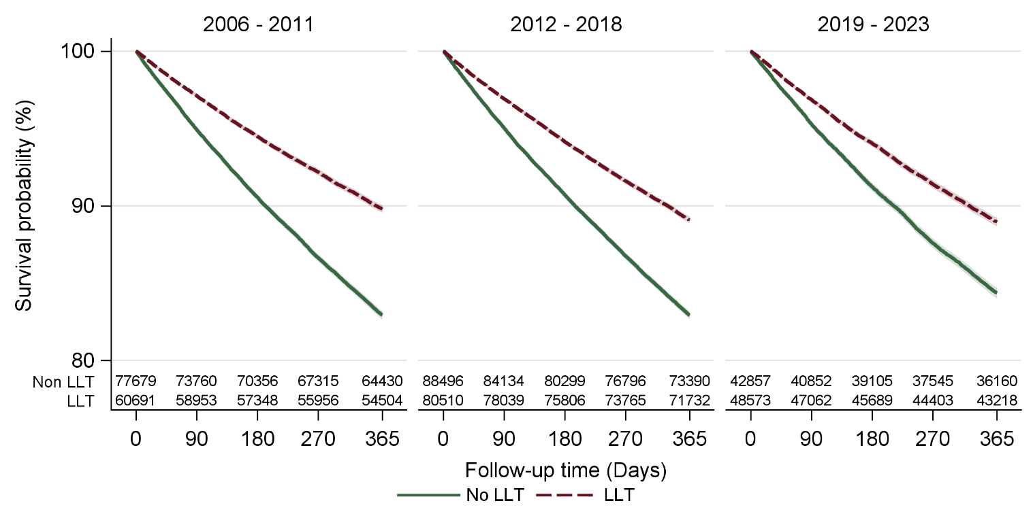

Figure 2.2. Kaplan-Meier plot of one-year all-cause mortality for lipid lowering therapy (Yes vs No) from 6 months after index date, by sex (FAS population)

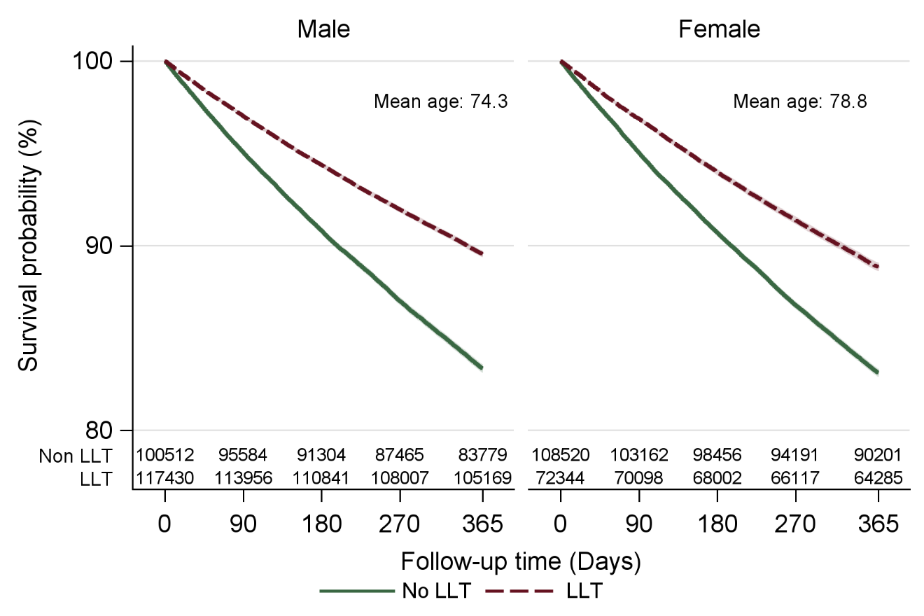

Figure 2.3. Kaplan-Meier plot of one-year all-cause survival for lipid lowering therapy (Yes vs No) from 6 months after index date, by ischemic heart disease (IHD: Yes vs No) 30 days prior to index (FAS population)

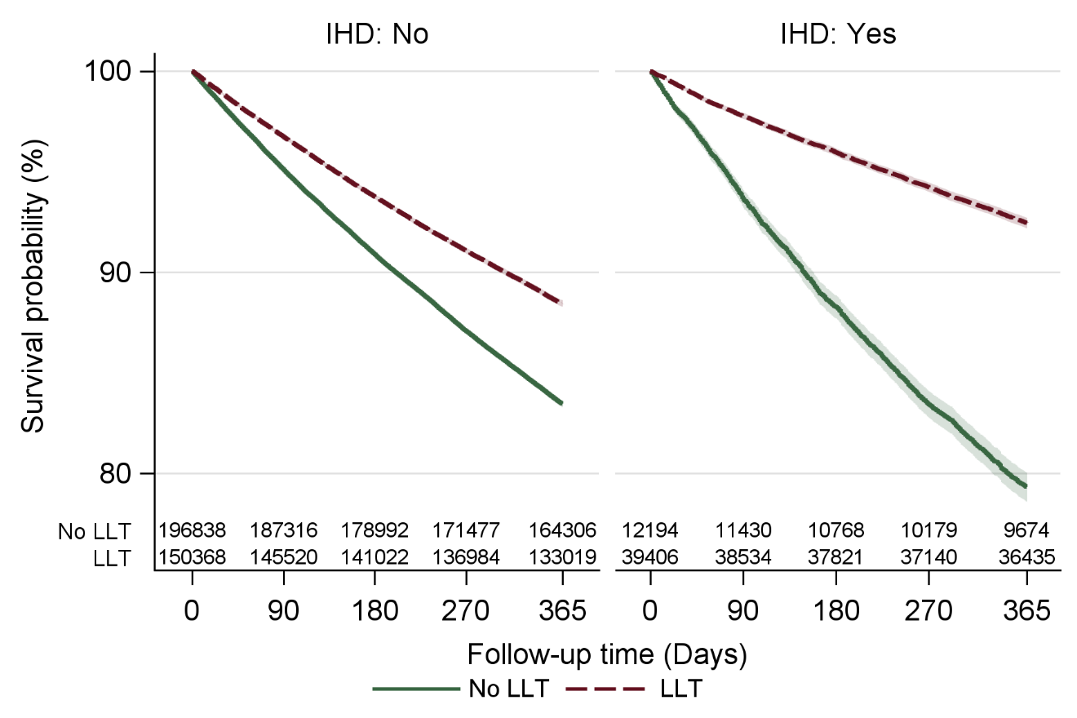

Figure 2.4. Kaplan-Meier plot of one-year all-cause survival for lipid lowering therapy from 6 months after index date, by different age groups (<75 vs >=75 years) (FAS population)
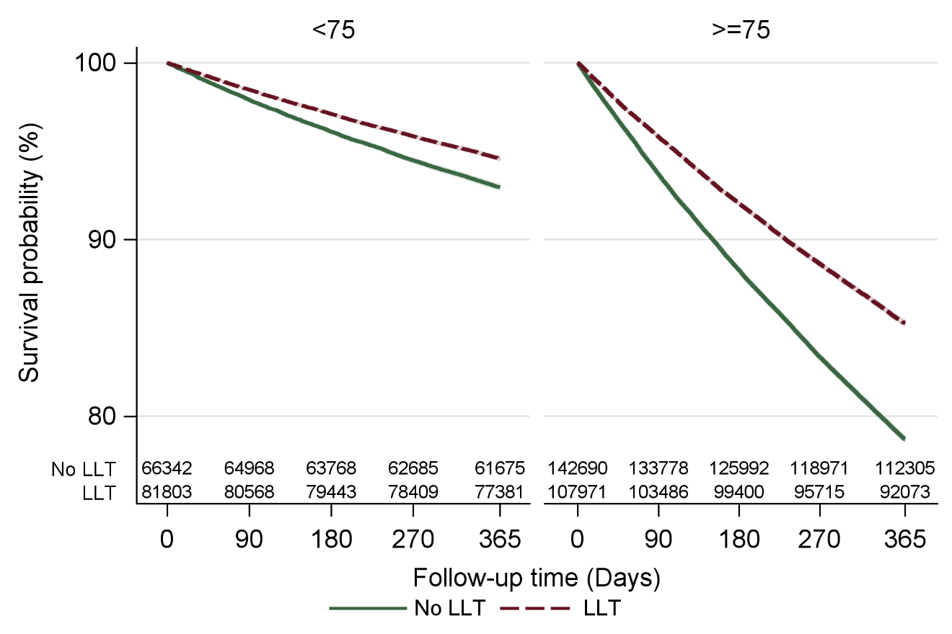

Figure 3.1. Kaplan-Meier plot for the secondary outcomes for lipid lowering therapy (Yes vs No), from 6 months after index date (FAS population)
